**PROOFS for Selenium IDE Lab Demo learnings**

**Lab 1: Example (Basic Selenium IDE Flow)**

|  |  |
| --- | --- |
| **Goals** | * **Understand the process of automation testing of a web application on Selenium IDE** * **Learn to manage document spacing** |
| **Time** | **60 minutes** |

**Basic URL:** [*https://tutorialsninja.com/demo/index.php?*](https://tutorialsninja.com/demo/index.php?)

**Proof:** Refer the image below for Demo 1

**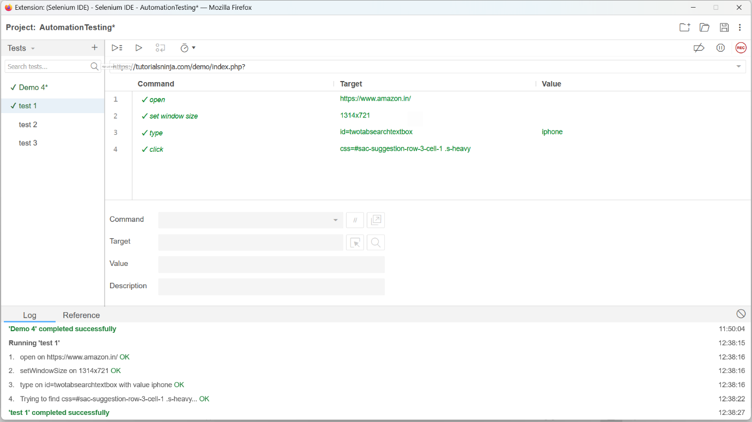  
  
Status:** Done

**Lab 2: Learning Selenium IDE (Modifications)**

|  |  |
| --- | --- |
| **Goals** | * **Understand the process of automation testing of a web application on Selenium IDE** * **Learn to manage document spacing** |
| **Time** | **60 minutes** |

**Basic URL:** [*https://tutorialsninja.com/demo/index.php?*](https://tutorialsninja.com/demo/index.php?)

**Proof:** Refer the image below for Demo 2

**  
  
Status:** Done

**Lab Demo 3: Learning Selenium IDE(Basic Flow)**

|  |  |
| --- | --- |
| **Goals** | * **Understand the process of automation testing of a web application on Selenium IDE** * **Learn to manage document spacing** |
| **Time** | **60 minutes** |

**Basic URL:** [*https://tutorialsninja.com/demo/index.php?*](https://tutorialsninja.com/demo/index.php?)

**Proof:** Refer the image below for Demo 3

**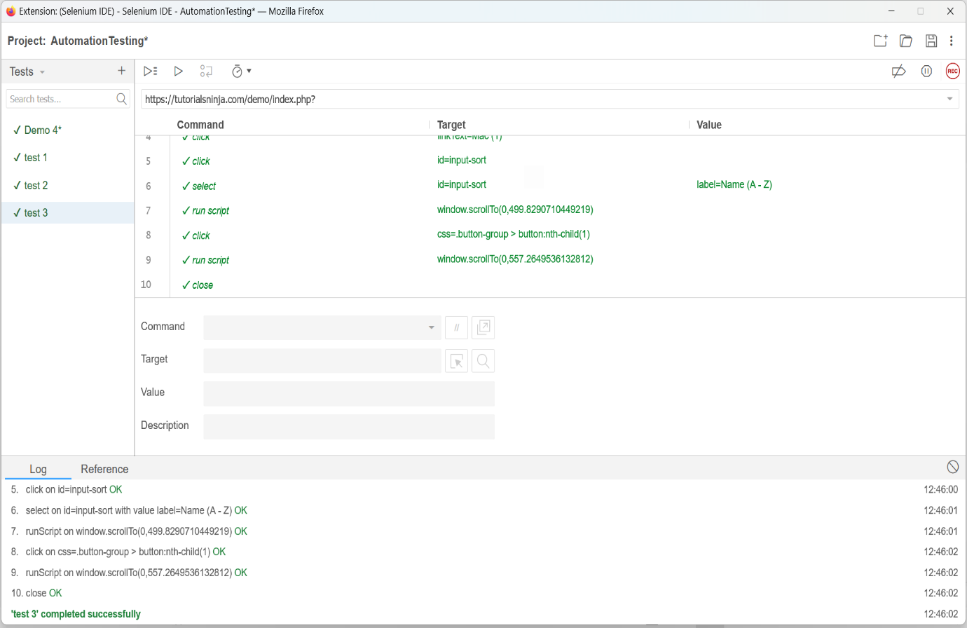  
  
Status:** Done

**Lab Demo 4: Learning Selenium IDE (Performing**

**Validations)**

|  |  |
| --- | --- |
| **Goals** | * **Understand the process of automation testing of a web application on Selenium IDE** * **Learn to manage document spacing** |
| **Time** | **60 minutes** |

**Basic URL:** [*https://tutorialsninja.com/demo/index.php?*](https://tutorialsninja.com/demo/index.php?)

**Proof:** Refer the image below for Demo 4

**  
  
Status:** Done